**Infection Prevention Control Policy**

|  |  |  |  |  |
| --- | --- | --- | --- | --- |
| **Version:** | **Date ratified** | **Name and title** | **Name and title** | **Next review due:** |
| 1 | 09/06/2020 | Judith Pashley. Practice Nurse | L Gardiner, PM | July 2022 |
| Reviewed | 25/5/2023 | Lorna Gardiner |  | Sept 2025 |
|  |  |  |  |  |
|  |  |  |  |  |
|  |  |  |  |  |

**Table of contents**

1 Introduction 2

1.1 Policy statement 2

1.2 Status 2

1.3 Training and support 2

2 Scope 2

2.1 Who it applies to 2

2.2 Why and how it applies to them 2

3 Guidance 2

3.1 Policy incorporation 2

3.2 Compliance 3

3.3 Annual IPC statement 3

3.4 Guidance documentation 4

3.5 Summary 4

Annex A – Infection Control Biological Substances Protocol 5

Annex B – Infection Control Inspection Checklist 8

Annex C – Clinical Waste Management Protocol 13

Annex D – Disposable (Single-Use) Intruments Protocol 16

Annex E – Needle-Stick Injury Protocol 18

Annex F – Safe use and disposal of sharps 21

Annex G – Sample Handling Protocol 25

Annex H – Sterilisation and Decontamination Protocol 27

Annex I – Isolation of Patients Protocol 30

Annex J – Notifiable diseases 35

Annex K – Toys in reception/waiting areas 37

Annex L – Staff exclusion from work 38

Annex M – Hand hygiene audit 40

# Introduction

## Policy statement

The purpose of this document is to ensure that SWAVESEY SURGERY remains committed to the prevention of healthcare-associated infection and that patient safety is the utmost priority. Good management and organisational processes are crucial to ensure that high standards of infection prevention (including cleanliness) are maintained.

## Status

This document and any procedures contained within it are non-contractual and may be modified or withdrawn at any time. For the avoidance of doubt, it does not form part of your contract of employment.

## Training and support

The practice will provide guidance and support to help those to whom it applies to understand their rights and responsibilities under this policy. Additional support will be provided to managers and supervisors to enable them to deal more effectively with matters arising from this policy.

# Scope

## Who it applies to

This document applies to all employees of the practice and other individuals performing functions in relation to the practice, such as agency workers, locums and contractors.

## Why and how it applies to them

Good infection prevention and control (IPC) is essential to ensure that people who use primary care services receive safe and effective care. Swavesey Surgery is committed to providing effective IPC procedures to minimise the risk of infection and to ensure the safety of patients, visitors and staff alike.

The practice aims to design and implement policies and procedures that meet the diverse needs of our service and workforce, ensuring that none are placed at a disadvantage over others, in accordance with the Equality Act 2010. Consideration has been given to the impact this policy might have in regard to the individual protected characteristics of those to whom it applies.

# Guidance

## Policy incorporation

This policy incorporates the following protocols (as annexes):

* Infection Control Biological Substances Protocol
* Infection Control Inspection Checklist
* Clinical Waste Management Protocol
* Disposable (Single-Use) Instruments Protocol
* Needle-Stick Injuries Protocol
* Safe use and disposal of sharps
* Sample Handling Protocol
* Sterilisation and Decontamination Protocol
* Isolation of Patients Protocol
* Notifiable diseases
* Toys in reception/waiting areas
* Staff exclusion from work

## Compliance

Swavesey Surgery ensures compliance with the Health and Social Care Act 2008 Code of Practice criteria[1] which are:

1. Systems to manage and monitor the prevention and control of infection
2. Provide and maintain a clean and appropriate environment in managed premises which facilitates the prevention and control of infections
3. Ensure appropriate antimicrobial use to optimise patient outcomes and to reduce the risk of adverse events and antimicrobial resistance
4. Provide suitable, accurate information on infections to service users, their visitors and any person concerned with providing further support or nursing/medical care in a timely fashion
5. Ensure prompt identification of people who have, or are at risk of developing, an infection so that they receive timely and appropriate treatment to reduce the risk of transmitting infection to other people
6. Systems to ensure that all care workers (including contractors and volunteers) are aware of and discharge their responsibilities in the process of preventing and controlling infection
7. Provide or secure adequate isolation facilities
8. Secure adequate access to laboratory support as appropriate
9. Have and adhere to policies that are designed for the individual’s care and provider organisations that will help to prevent and control infections
10. Providers have a system in place to manage the occupational health needs and obligations of staff in relation to infection

## Annual IPC statement

The annual IPC statement details the risk assessments undertaken and subsequent recommendations regarding IPC. In addition, the statement also details IPC-related Significant Events and audits completed.

The Health and Social Care Act 2008 - Code of Practice on the prevention and control of infections and related guidance[2] (Appendix D) states that the IPC lead is to prepare an annual statement, *“for anyone who wishes to see it, including patients and regulatory authorities”.* This short review should include the following:

* Known infection transmission event and actions arising from this
* Audits undertaken and subsequent actions
* Risk assessments undertaken for the prevention and control of infection
* Education and training received by staff
* Review and update of policies, procedures and guidance

In addition to this, it is considered that this report should include any actions relating to any significant event that has occurred during the reporting period.

To meet the above HSCA directive of “anyone who wishes to see it”, this statement is to be placed on the practice website.

## Guidance documentation

Swavesey Surgery refers to the guidance detailed in the annexes of this policy, which are related to infection prevent and control, whilst also referring to:

[The Health and Social Care Act 2008](https://www.gov.uk/government/uploads/system/uploads/attachment_data/file/449049/Code_of_practice_280715_acc.pdf)

[NICE Guidelines – IPC](https://www.nice.org.uk/guidance/qs61/chapter/Introduction)[NICE Guidance – Healthcare-associated Infections](https://www.nice.org.uk/guidance/cg139)

## Summary

All staff undertake infection prevention and control training and are committed to maintaining high standards of infection prevention and cleanliness within Swavesey Surgery. Regular training, audit and reviews are key to the prevention of healthcare-associated infection.

## Annex A – Infection Control Biological Substances Protocol

**Introduction**

A biological agent is defined as a microorganism, cell culture or human endoparasite, whether or not genetically modified, which may cause infection, allergy, toxicity or otherwise create a hazard to human health[3]*.*

**Overview**

Healthcare workers will come into contact with a number of sources of infection, be it directly or indirectly, such as:

* Blood and bodily fluids
* Faeces, urine and vomit
* Direct skin contact
* Respiratory secretions and excretions

Staff must ensure that they adhere to the guidelines given in this document as well as regional and national guidelines. All staff at Swavesey Surgery are given training in IPC at induction and will also receive annual refresher training.

**Spillages**

There may be occasions when exposure occurs despite careful attention to the correct procedures. If such incidents occur within the practice, a spill kit should be used. At Swavesey Surgery, the spill kits are stored in the Treatment Room and in Reception. Only personnel trained in the use of this kit are authorised to use it.

**Immediate actions**

In the event of a spillage, the following actions are to be taken:

1. The spillage should be dealt with as soon as possible.
2. Staff, patients and visitors must be kept away from the spillage and if possible a warning sign shown, while preparation is made to manage the spill.
3. Put on personal protective equipment (PPE) found in the body fluid disposal kit held in reception.

**Management of spills**

•   Small blood spills onto hard surfaces: Wearing gloves, clean with universal/detergent wipes and dispose as clinical waste.

•   Large blood spills, e.g. spills onto floor (except urine): Use a body fluid disposal kit, these are held in reception, and follow the instructions. Wash area with detergent and water.

•   Very large blood spills including smears to walls, etc: Wearing gloves and apron, use spill wipes and leave to absorb for 30 seconds. Wipe, allowing the rest of the spill to be absorbed (if a larger spill), use the wipe contained within the pack to clean the area, place back into the bag, seal and dispose of in clinical waste.

•   Blood-stained urine spills – DO NOT USE blood spillage kit: Wearing gloves and aprons, soak up urine with paper towels. Then wash areas with detergent followed by chlorine dioxide solution (Tristel).

•   Urine/vomit spills: Wearing gloves and an apron, use the urine/vomit spillage kit and follow the instructions on the packet. Wash with detergent and water. If urine/vomit spillage kit not available, soak up urine/vomit with disposable towels. Then wash area with detergent.

•   Spills onto carpets or soft furnishings: Wearing gloves and apron, soak up spillage with paper towels then clean with detergent and water. Then, for carpets, steam clean or for soft furnishings launder or dry clean. If item remains soiled it must be disposed of.

**Further actions and guidance**

All incidents are to be reported to Lisa Norris / Judith Pashley in the first instance.

Instructions for using spill wipes are shown on the next page.

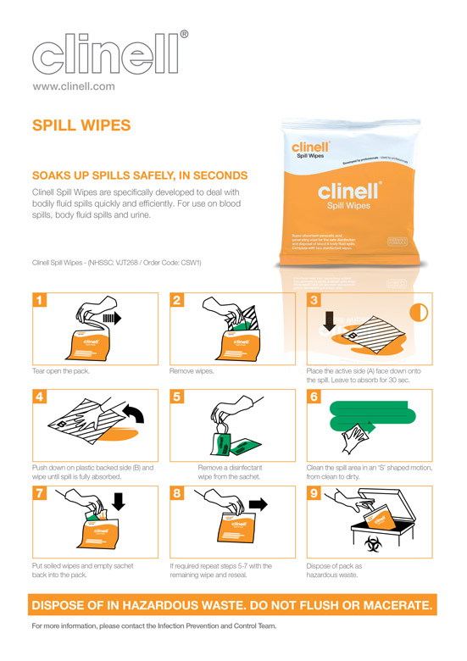

## 

## Annex B – Infection Control Inspection Checklist

**Introduction**

The purpose of this document is to enable Swavesey Surgery to assess how it meets the standards for a managed environment which minimises the risk of infection to patients, staff and relatives. These standards reflect current legislation, national guidelines and good practice regarding infection control within a healthcare environment.

**Usage**

The checklist overleaf should be used as a guide and in conjunction with national guidelines. Each consulting room/treatment area, etc. should have an independent assessment completed and annotated on a separate form.

**Summary**

This checklist is not exhaustive and will need to be adapted to reflect building modifications, changes in practices, etc. The nominated IPC lead at Swavesey Surgery will review this document annually to ensure accuracy and relevance.

**Infection Prevention Control Checklist**

|  |  |  |  |  |
| --- | --- | --- | --- | --- |
| Management of IPC | Yes | No | N/A | Comments |
| Is there a named lead person responsible for infection prevention and control? | X |  |  | Mandy Bagstaff, HCA |
| Are these responsibilities detailed in the individual’s job description? |  |  |  |  |
| Are infection prevention and control-related topics agenda items at practice meetings? |  |  |  |  |
| Is there evidence of a process for reporting incidents in relation to IPC? |  |  |  |  |
| Are there up-to-date local contact telephone numbers available from which to obtain advice pertaining to IPC? |  |  |  |  |
| Is there evidence that audits have been undertaken and practice changed regarding IPC? |  |  |  |  |
| Are there local risk assessments held relating to IPC? |  |  |  |  |

|  |  |  |  |  |
| --- | --- | --- | --- | --- |
| Staff training pertaining to IPC | Yes | No | N/A | Comments |
| Is IPC included in all staff induction programmes? |  |  |  |  |
| Have staff received mandatory training in IPC? |  |  |  |  |
| Is there a process in place to ensure that all non-attendees at mandatory training are followed up? |  |  |  |  |

|  |  |  |  |  |
| --- | --- | --- | --- | --- |
| IPC policy and protocols | Yes | No | N/A | Comments |
| Are policies and protocols available to all staff? |  |  |  |  |
| Are cleaning schedules in place and displayed in all areas? |  |  |  |  |
| Are SLAs monitored and reviewed? |  |  |  |  |
| Is there evidence of reviews of policies and protocols? |  |  |  |  |
| Are audits regularly undertaken to review standards and procedures? |  |  |  |  |

|  |  |  |  |  |
| --- | --- | --- | --- | --- |
| General IPC standards | Yes | No | N/A | Comments |
| Is the environment visibly clean and free from any damage? |  |  |  |  |
| Is furniture made of impermeable and washable materials? |  |  |  |  |
| Are all furnishings and fittings visibly clean and in a good state of repair? |  |  |  |  |
| Is the floor visibly clean and in a good state of repair? |  |  |  |  |
| Is the environment generally free from clutter? |  |  |  |  |
| Are items such as telephones and IT equipment clean and in a good state of repair? |  |  |  |  |

|  |  |  |  |  |
| --- | --- | --- | --- | --- |
| Toilet IPC standards | Yes | No | N/A | Comments |
| Are the toilet environments visibly clean and free from any damage? |  |  |  |  |
| Are all furnishings and fittings visibly clean and in a good state of repair? |  |  |  |  |
| Are all dispensers clean and in a good state of repair? |  |  |  |  |
| Are paper towels available from an enclosed dispenser? |  |  |  |  |
| Is there a promotional hand hygiene poster displayed? |  |  |  |  |
| Is there a hands-free domestic waste bin available, and is it in a good state of repair, clean and labelled appropriately? |  |  |  |  |
| Are there appropriate facilities for the disposal of sanitary waste? |  |  |  |  |
| Is the flooring in a good state of repair, clean and impervious to moisture? |  |  |  |  |

|  |  |  |  |  |
| --- | --- | --- | --- | --- |
| Baby-changing facilities IPC standards | Yes | No | N/A | Comments |
| Is the environment visibly clean and free from any damage? |  |  |  |  |
| Are all furnishings and fittings visibly clean, in a good state of repair and made from impermeable, washable materials? |  |  |  |  |
| Is there a dedicated basin for hand washing, and is it clean and in a good state of repair? |  |  |  |  |
| Are all dispensers clean and in a good state of repair? |  |  |  |  |
| Are paper towels available from an enclosed dispenser? |  |  |  |  |
| Is there a promotional hand hygiene poster displayed? |  |  |  |  |
| Is there a hands-free domestic waste bin available, and is it in a good state of repair, clean and labelled appropriately? |  |  |  |  |
| Is there a hands-free waste bin available for nappy disposal and is it in a good state of repair, clean, labelled appropriately? |  |  |  |  |
| Are instructions for parents displayed on how to clean the facilities after use and are cleaning materials available? |  |  |  |  |
| Are the changing mats in a good state of repair, intact and clean? |  |  |  |  |
| Is the flooring in a good state of repair, clean and impervious to moisture? |  |  |  |  |

|  |  |  |  |  |
| --- | --- | --- | --- | --- |
| Treatment & consulting room IPC standards | Yes | No | N/A | Comments |
| Is the environment visibly clean and free from any damage? |  |  |  |  |
| Are all furnishings and fittings visibly clean, in a good state of repair and made from impermeable, washable materials? |  |  |  |  |
| Is the flooring in a good state of repair, clean and impervious to moisture? |  |  |  |  |
| Is there a dedicated basin for hand washing, and is it clean and in a good state of repair? |  |  |  |  |
| Are sensor or elbow taps available? |  |  |  |  |
| Are all dispensers clean and in a good state of repair? |  |  |  |  |
| Are paper towels available from an enclosed dispenser? |  |  |  |  |
| Is there a promotional hand hygiene poster displayed? |  |  |  |  |
| Is there a hands-free domestic waste bin available for paper towels, and is it in a good state of repair, clean and labelled appropriately? |  |  |  |  |
| Are alcohol-based hand-rub bottles wall-mounted in treatment rooms? |  | X |  | Discuss at next meeting |
| Is there a designated work surface/trolley for clinical procedures, and is it clean and in a good state of repair? |  |  |  |  |
| Are all items stored above floor level and are there appropriate storage facilities? |  |  |  |  |
| Are all areas visibly clean (shelving, cupboards, drawers, etc.)? |  |  |  |  |
| Are patient examination couches/chairs clean and in a good state of repair? |  |  |  |  |
| Is the paper roll on couches replaced between patients? |  |  |  |  |
| Are disposable curtains in date and marked with an expiry date? |  |  |  |  |
| Is there a hands-free clinical waste bin available, and is it clean, free from damage and labelled appropriately? |  |  |  |  |
| Is the drug fridge only used for the storage of drugs? |  |  |  |  |
| Is there PPE readily available in the treatment/consulting rooms? |  |  |  |  |
| Are sharps containers correctly assembled, labelled with a date, location and signed? |  |  |  |  |
| Are all sharps bins free from protruding sharps, with contents below the ‘fill’ line? |  |  |  |  |
| Are the lids closed between usage and bins out of the reach of vulnerable patients? |  |  |  |  |
| Are sharps disposed of safely and not resheathed? |  |  |  |  |
| Are full/locked sharps bins stored appropriately, away from public access until collected for disposal? |  |  |  |  |

|  |  |  |  |  |
| --- | --- | --- | --- | --- |
| Staffroom/kitchen IPC standards | Yes | No | N/A | Comments |
| Is the environment visibly clean and free from any damage? |  |  |  |  |
| Are all furnishings and fittings visibly clean, in a good state of repair and made from impermeable, washable materials? |  |  |  |  |
| Is the flooring in a good state of repair, clean and impervious to moisture? |  |  |  |  |
| Are all items stored appropriately and off the floor? |  |  |  |  |
| Is the environment tidy and free from clutter? |  |  |  |  |
| Is staff food placed in the fridge, correctly labelled with names and dates, and with expiry dates? |  |  |  |  |
| Is the fridge free from medicines/drugs? |  |  |  |  |

Date inspection completed:

Inspection completed by: Lisa Norris Student Nurse Apprentice Infection control lead

This document should be retained as it can be used as evidence in an IPC audit.

## Annex C – Clinical Waste Management Protocol

**Introduction**

NHS England’s framework agreement sets out consistent standards for the collection and disposal of clinical waste from practices. The framework identifies a number of benefits including quality standards, consistency, management of contracts and value for money. Clinical waste can be defined as any waste produced by, and as a consequence of, healthcare activities[4]. At Swavesey Surgery the approved contractor is SCRL.

**Overview**

Under the [Environmental Protection Act 1990](http://www.legislation.gov.uk/ukpga/1990/43/contents) it is unlawful to deposit, recover or dispose of controlled (including clinical) waste without a waste management licence, contrary to the conditions of a licence or the terms of an exemption, or in a way that causes pollution of the environment or harm to human health[5]. Hazardous healthcare waste is subject to the requirements of the [Hazardous Waste Regulations 2005](https://www.gov.uk/government/uploads/system/uploads/attachment_data/file/218704/haz-waste-regs-guide.pdf).

**Aim**

The aim of this protocol is to minimise the risks associated with clinical waste, particularly handling and disposal at Swavesey Surgery. Throughout this protocol, the term clinical waste refers to “hazardous waste” generated by practices in England, Wales and Northern Ireland or “special waste” in Scotland. This protocol is to be read in conjunction with the references in the footnotes and hyperlinks within the document.

**Waste segregation**

Segregation on-site is vital to ensure that waste is stored, transported and ultimately disposed of in the correct manner to maintain compliance with extant regulations. Clinical waste must be segregated as detailed overleaf.

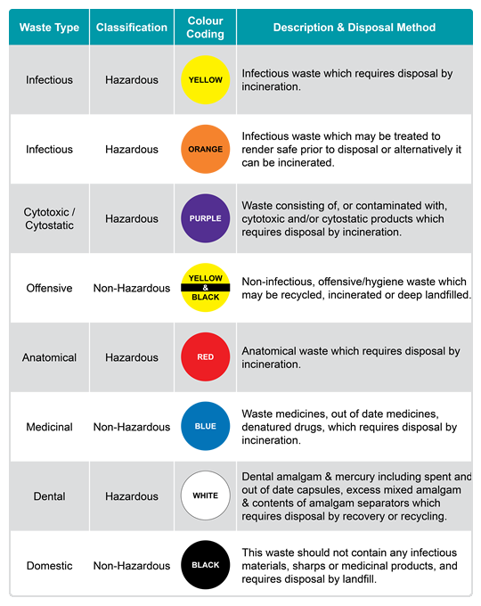

Source: Murray Medical UK – Segregation of Clinical Waste[6]

**Handling of waste**

Clinical waste is classed as hazardous material and must therefore be handled and disposed of in a safe manner to ensure that personnel are not injured or exposed to contamination.

All personnel, when involved in the handling of clinical waste, should use the correct PPE; it is essential that staff have received IPC training before handling clinical waste. The minimum PPE requirements when handling clinical waste are gloves and an apron.

Clinical waste bins must be emptied on a daily basis and bags must not be filled more than three quarters full. Waste must be taken to the Garage and placed in the correct receptacle whilst awaiting collection from SCRL. Access to this area is for authorised personnel only; all staff must ensure that they secure the area when leaving. If this area is inaccessible, Lisa Norris / Judith Pashley is to be informed and alternative arrangements made for the safe storage of the clinical waste.

**Collection**

All clinical waste will be collected by SCRL weekly on a Thursday and is to be supported with a Waste Transfer Note[7] (WTN). Copies are to be retained by the Reception team to evidence the correct and authorised removal of waste from the site. Hazardous waste requires a consignment note[8] (provided by the contractor) which must be retained for audit purposes.

**Summary**

All staff have a duty of care to ensure that waste is correctly segregated. Compliance with this protocol and the references within it will ensure the safe and effective management of waste at Swavesey Surgery Any questions relating to this protocol are to be directed to Lorna Gardiner- Practice Manager.

## Annex D – Disposable (Single-Use) Intruments Protocol

**Introduction**

This protocol details the management of single-use items at Swavesey Surgery . Single-use items are those items that are to be used on one patient, for a single procedure and then disposed of correctly. Reusing a single-use item could expose both staff and patients to unnecessary risks.

**Overview**

Single-use items are commonly used within the primary care environment. Whilst items held will vary depending on individual preferences, the management of such items remains the same. At Swavesey Surgery, Lisa Norris is responsible for the ordering of medical stores, including single-use items.

**Identifying single-use items**

Single-use items have an identifier which clearly shows they are single-use only. This symbol is usually on the packaging of the item and may not be on the item itself. If there is any doubt, contact the manufacturer for further guidance.

The symbol that indicates single use is shown below:



Any item that displays this symbol can only be used on one individual, for a single procedure. Once used, the item must be disposed of correctly, following Swavesey Surgery’s clinical waste protocol.

**Safety implications**

There are a number of safety implications[9] regarding the reuse of single-use items, which clearly explain the risks of reusing an item intended for single use.

Such implications are:

* Reprocessing single-use devices may compromise their intended function
* Single-use devices may not be designed to allow thorough decontamination and (if applicable) re-sterilisation processes
* Reprocessing a single-use device may alter its characteristics so that it no longer complies with the original manufacturer’s specifications and therefore the performance may be compromised
* Single-use devices have not undergone extensive testing, validation and documentation to ensure the devices are safe to reuse

**Responsibility**

Any individual who reuses an item identified for single use only, bears full responsibility for the safety and effectiveness of its function; such actions are against the guidance of the Medicines and Healthcare Products Regulatory Agency (MHRA).

**Summary**

Single-use items are specifically manufactured for the purpose of being used once. The risks associated with reusing such items clearly outweigh the benefits. Reusing items exposes patients and staff to the risk of infection and transfers the responsibility from the manufacturer to the individual. At Swavesey Surgery training is delivered on a regular basis to ensure that all staff are aware of this protocol and adhere to the single-use policy.

## Annex E – Needle-Stick Injury Protocol

**Introduction**

Sharps injuries are a well-known risk to workers in healthcare, and for those who receive them they can cause anxiety and distress. For the purpose of this protocol, sharps injuries are defined as injuries sustained from needles, scalpels and other instruments which can cause injury by cutting or pricking the skin. This protocol gives detailed guidance for the management of sharps injuries at Swavesey Surgery.

**Overview**

Anyone working at Swavesey Surgery is at risk from a sharps injury; this includes healthcare workers or clinicians but also non-clinical members of staff who may be at risk if sharps are not stored or disposed of correctly. All employers are required under existing health and safety law to ensure that risks from sharps injuries are adequately assessed and appropriate control measures are in place[10].

**Minimising risk**

Everyone has a duty of care to minimise the risk of exposure to sharps injuries at Swavesey Surgery. The following actions will further reduce the risk of exposure[11]:

* No needle recapping or resheathing
* Availability of portable sharps containers
* Adequate number and placing of sharps containers within arm’s reach
* Disposing of sharps immediately at the point of use in designated sharps containers
* Sealing and discarding sharps containers when they are three quarters full
* Establishing means for the safe handling and disposal of sharps devices before the beginning of a procedure

**Management of sharps injuries**

All staff need to be familiar with the immediate management procedure, both for themselves if they become injured and for assisting injured colleagues. The management of sharps injuries is shown in the infographic overleaf.

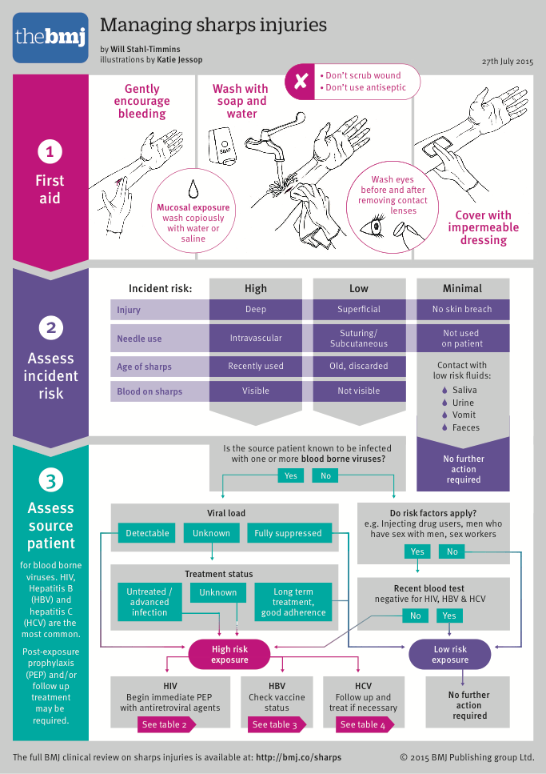

Source: The BMJ: <http://www.bmj.com/content/bmj/suppl/2015/07/29/bmj.h3733.DC1/sharps_infographic_web_sm3.pdf>

**Reporting sharps injuries**

At Swavesey Surgery all sharps injuries are to be reported to Judith Pashley / Lisa Norris. In addition, report the incident to the duty doctor. It may be necessary to gain further advice from Health protection agency please see <https://www.cambridgeshireandpeterboroughccg.nhs.uk/easysiteweb/getresource.axd?assetid=17178&type=0&servicetype=1> for more information.

Sharps injuries must be [reported to HSE](http://www.hse.gov.uk/riddor/report.htm)[12] under the Reporting of Injuries, Diseases and Dangerous Occurrences Regulations 1995 (RIDDOR) if:

* An employee is injured by a sharp known to be contaminated with a blood-borne virus (BBV), e.g. hepatitis B or C or HIV. This is reportable as a dangerous occurrence
* The employee receives a sharps injury and a BBV acquired by this route seroconverts. This is reportable as a disease
* The injury itself is so severe that it must be reported

If the sharp is not contaminated with a BBV, or the source of the sharps injury cannot be traced, it is not reportable to HSE unless the injury itself causes an over-seven-day injury. If the employee develops a disease attributable to the injury, then it must be reported.

**Recording of sharps injuries at Swavesey Surgery**

All sharps injuries sustained at Swavesey Surgery must be recorded using Incident form. It is the responsibility of the person suffering a sharps injury to ensure that it is reported/recorded appropriately. If they are unsure, they should discuss the incident with Judith/Lisa or Dr Jain.

**Further actions**

To raise awareness and to minimise the risk of future occurrences, a sharps injury should be recorded as a Significant Event and discussed at the next practice meeting, where lessons identified can be discussed and any additional training delivered.

**Summary**

Sharps injuries are not uncommon within primary care. Due diligence and adherence to guidance and legislation will reduce the risk to all staff. Annual training is mandatory at Swavesey Surgery to maintain an awareness of the significance of the safe management of sharps.

## Annex F – Safe use and disposal of sharps

**Introduction**

Many sharps injuries can be avoided by adhering to the principles of safe practice at Swavesey Surgery. The incidence of sharps injuries in primary care is surprisingly high. Care is to be taken at all times to ensure the safe use and disposal of sharps.

**Legislation**

There are a number of legislative acts and laws governing the safe use and disposal of sharps:

* C[ontrol of Substances Hazardous to Health (COSHH) 2002](http://www.legislation.gov.uk/uksi/2002/2677/pdfs/uksi_20022677_en.pdf)
* [Management of Health and Safety at Work Regulations 1999](http://www.legislation.gov.uk/uksi/1999/3242/contents/made)
* [The Provision and Use of Work Equipment Regulations 1998](http://www.hse.gov.uk/work-equipment-machinery/puwer.htm)
* [Reporting of Diseases, Injuries and Dangerous Occurrences Regulations 2013 (RIDDOR)](http://www.hse.gov.uk/riddor/)
* [The Personal Protective Equipment Regulations 1992](http://www.hse.gov.uk/pubns/indg174.pdf)
* [Health and Safety (First Aid) Regulations 1981](http://www.hse.gov.uk/firstaid/legislation.htm)
* [Safety Representatives and Safety Committee Regulations 1977](http://www.hse.gov.uk/involvement/1977.htm)

**EU directive**

In addition to the above, an EU directive was introduced in 2010 aimed at protecting healthcare workers from sharps injuries ([Directive 2010/32/EU](http://eur-lex.europa.eu/legal-content/EN/TXT/?uri=celex%3A32010L0032)). From this directive a [transposition note](http://www.hse.gov.uk/aboutus/europe/transposition/tn-2010-32-eu.pdf) was produced detailing which aspects of the directive were to be incorporated into The Health and Safety (Sharp Instruments in Healthcare) Regulations 2013[13]. Healthcare workers should adhere to the information detailed in these regulations when searching for guidance/information.

**Safe use principles**

The following principles should be followed at Swavesey Surgery:

* Never pass sharps from person to person by hand – use a safe area or receptacle to place them in
* Never walk around the room/practice with an exposed sharp in your hand
* Never leave sharps lying around – dispose of them appropriately
* Dispose of syringes and needles as a single unit – do not remove the needle first
* Never resheathe a needle
* If you are administering care to a confused patient, have help present to minimise the risk of injury to the patient and yourself

**Disposal**

In addition to the above, the safe use of sharps bins is also essential to reduce the risk of exposure. The Sharps Regulations require that clearly marked and secure containers be placed close to the area where sharps are used. Instructions for staff on safe disposal of sharps must also be placed in those areas[14].

To comply with the regulations, the following guidance is to be adhered to:

* Ensure that sharps bins are of an appropriate size for the clinical activity
* Sharps bins should be available at the point of use of the sharp
* Sharps bins should be located at approximately waist height, but out of the reach of children or confused adults
* Between usages, the temporary closure device should be used to prevent accidental exposure if the bin is knocked over
* Only fill the bin to the ‘fill line’
* Used/full sharps bins must be placed in a locked, segregated cupboard or clinical waste bin provided for such a purpose

See next page for an image regarding the safe use of sharps bins.

**Correct use of sharps bins**

**Sharps bin management is the responsibility of the clinician using the bin, not the cleaning team.**

When assembling sharps bins, staff must ensure the following:

* The bin lid and label are a colour match and the bin is of the correct size
* The lid is fully secured and ‘clicked’ into place
* The label is completed legibly, with the name of the individual assembling the bin, the date assembled and the location of the bin

Do ensure that. when not in use, the lid window is “temporarily” closed.

Do replace the bin one month after the date of assembly (unless ¾ full prior to this date).

Do not overfill the bin! Once the bin is ¾ full, close the lid securely.

When closing sharps bins, staff are to ensure:

* The lid window is clicked into the closed position
* The date of closure is annotated on the label and signed by the member of staff
* The bin is taken to the clinical waste area

**Colour-coded sharps bins**

The image below illustrates the uses and colours of sharps bins:

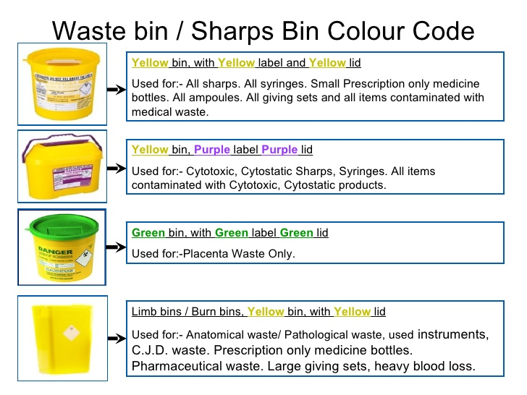

**Summary**

The safe use of sharps and their subsequent safe disposal will reduce the risk of injury to all staff and patients at [insert practice name]. Any queries relating to safe sharps management and disposal should be directed to [insert name and role] in the first instance.

Supplementary guidance can be found by accessing the hyperlinks within this document or the references at the footnotes.

## Annex G – Sample Handling Protocol

**Introduction**

Staff at Swavesey Surgery may at times be expected to handle specimens/samples from patients. This protocol details the guidance for the safe handling of specimens for all staff, including non-clinical members*.

**Overview**

Clinical specimens are often referred to as samples by patients. A clinical specimen can be defined as any substance (solid or liquid) taken from the patient for the purpose of analysis. All staff at Swavesey Surgery have received the required training to ensure that specimens are handled safely. It remains the responsibility of all staff to ensure that they adhere to best practice and the guidance provided.

**Handling**

Specimens if not handled correctly are a risk of infection to all personnel involved, including healthcare workers, transport staff and laboratory personnel. Specimens that are unlabelled, without a completed request form, in incorrect containers or that are leaking are unlikely to be processed by the laboratory. If in doubt, speak to anyone in nursing team, Judith Pashley or Lisa Norris.

All staff are to ensure the following:

* They are wearing the appropriate PPE, i.e. gloves
* The correct pathology request form has been used
* The correct specimen containers have been used
* The request form and container(s) have been labelled correctly, accurately and legibly
* Ensure a match between patient, form and container
* Ensure the above items are placed into the standard packaging for that container
* Place the package into the transportation container
* Dispose of PPE and wash hands
* Annotate the receipt of the specimen in the patient’s medical record

* MPS[15] recommend that reception staff do not touch patient specimens. Instead a box should be placed at reception for patients to leave their samples, which can then be passed to the clinical team for processing.

**Collection and transportation**

At Swavesey Surgery specimens are collected around 10.30 and 15.00 by City Sprint for onward transfer to Addenbrookes hospital. If the courier fails to arrive, inform Lisa/Judith as this may affect the viability of the specimens.

The packaging of specimens must consist of three components to comply with UN 3373 regulations[16]:

1. A primary receptacle – the specimen tube/pot
2. Secondary packaging – the plastic specimen bag
3. An outer packaging – the Verspak bag used to transport specimens to the laboratory

Example of a Verspak bag:

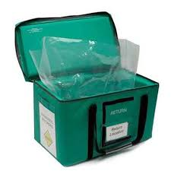

**Compromised specimens**

There may be occasions when concerns are raised either at Swavesey Surgery or the laboratory at Addenbrooke’s Hospital regarding the integrity of the sample. In such instances, there may be a requirement to raise a incident report, particularly if the specimen has leaked in a public area. However, communication will be maintained between both locations to determine (where possible) the cause.

Any incidents regarding specimens should be recorded as a Significant Event and discussed at the next practice meeting. Repeated incidents should indicate the requirement for an audit aimed at improving practice in the future.

**Summary**

It is the responsibility of the sender to collect and package specimens as per the guidance given in this protocol and the associated references. Staff must collect specimens safely and effectively as any undue delay may have a detrimental effect on patient care.

## Annex H – Sterilisation and Decontamination Protocol

**Introduction**

Within the primary care environment, the majority of practices are opting for single-use items; however there are some items that are reusable and therefore require sterilisation. At Swavesey Surgery the following items are used which require sterilisation:

* Transducer for Micromedical spirometer

This protocol details the procedure for the sterilisation of instruments at Swavesey Surgery, whilst also detailing the general cleaning and disinfecting of items within the practice.

**Overview**

The careful sterilisation of equipment used in primary care is essential to the effective delivery of patient care. This policy will provide guidance which conforms to national and local directives. The effective decontamination of equipment between uses is a fundamental element of infection control practices.

**Decontamination process**

The decontamination process, which ultimately leads to sterilisation, is a multi-faceted process consisting of:

1. Cleaning
2. Disinfecting
3. Sterilising

**Cleaning** involves the removal of dirt, debris, body fluids, etc. from the equipment. Cleaning precedes the disinfection process.

**Disinfecting** reduces the number of microorganisms but is not a fail-safe method to ensure that all spores are removed; this stage alone consists of many factors:

* Prior cleaning must be effective
* The use of the appropriate disinfectant and in the correct strength
* The disinfectant must be used correctly as per the manufacturer’s instructions

**Sterilising** is the only process that removes all microorganisms.

**Sterilisation of the Micromedical spirometer transducer**

Follow instructions for procedure using Perasafe powder, as per the Spirometry procedure and protocol on the Shared drive.

**Perasafe Instructions: www.numed.co.uk › documents › download › perasafe.**

**General decontamination**

The table below details the equipment/items held and used within Swavesey Surgery and the associated decontamination requirements:

|  |  |
| --- | --- |
| Equipment | Decontamination method |
| Airways | Single use |
| Ambu bags | Single use/clean with detergent followed by appropriate disinfectant |
| Auroscope ear pieces | Single use |
| Baby-changing mat | Cover with disposable paper between babies. Clean with detergent at end of the session. If contaminated with blood/body fluids, clean then disinfect before next baby in line with policy |
| Baby weighing scales | Cover with disposable paper between babies. Clean with detergent at end of the session. If contaminated with blood/body fluids, clean then disinfect before next baby in line with policy |
| Blood pressure equipment | Wipe cuff and monitor with detergent/detergent wipe, pat dry with paper towel between patient uses. Do not immerse cuff in water.  Disposable single-use cuff/cuff cover for use when a patient has a multi-resistant organism |
| Doppler ultrasound probe | Remove gel, clean with detergent/detergent wipe. Do not immerse in water |
| Ear syringe – Propulse | Follow disinfection procedure in Ear Care Procedure |
| Electrodes Straps/leads/machine | Clean body of machine and leads with detergent/detergent wipe. Do not immerse in water .  Electrodes are single-use. |
| Examination couches | Cover with disposable paper towel between patients. Clean with detergent at the end of the session.  Clean and disinfect with NaDCC if contaminated with blood/blood-stained body fluid |
| Minor surgical instruments | Disposable, single use |
| Nebulisers | Wipe body of machine with detergent wipe.  Mask, chamber and tubing are all single-use. |
| Peak flow meters/spirometry | Follow manufacturer’s guidance Disposable single-use mouthpieces with one-way valve or filter (change filter as directed by manufacturer)  Clean machine weekly with detergent/detergent wipe |
| Pillows | All pillows should be protected with plastic (sealed) or vapour-permeable cover Wipe with detergent/detergent wipe in between patients and at end of session  Disinfect with NaDCC if contaminated with blood/blood-stained body fluid |
| Pulse oximeter | Clean weekly with detergent/detergent wipe and between patients |
| Scissors | Single use  NB: Bandage/dressing scissors – clean between patients with detergent/detergent wipe, and disinfect if required |
| Stethoscope | Clean between each patient use, with detergent wipe |
| Sticks/frames/crutches | Clean with detergent/detergent wipe between users |
| Stitch/staple removers | Single use |
| Suction machines | Follow manufacturer’s guidance. Contact CES if further advice required |
| Thermometer | Disposable sheath for each patient Clean handpiece weekly with detergent/detergent wipes  Do not immerse in water |
| Tourniquet | Wipe with detergent/detergent wipe, pat dry with paper towel between patient use or: Disposable single patient use if appropriate in specific services. If reusable tourniquet grossly contaminated – dispose of. Ensure adequate supply available |
| Treatment chairs | Clean daily with detergent/detergent wipes |
| Trolleys | Clean with detergent/detergent wipe prior to/following use |
| Toys: Hard | Clean weekly with detergent/detergent wipe or after use if used as part of treatment/assessment All hard toys must be made of suitable material to withstand disinfection if required |
| Soft | Not suitable for healthcare facilities |
| Weighing scales | Clean weekly with detergent/detergent wipe |
| Wheelchair | Clean with detergent/detergent wipe after use |
| Work surfaces | Clean with detergent/detergent wipe at the end of each session |
| Vaginal speculum | Disposable, single use |

**Summary**

The effective decontamination of equipment and the appropriate use of single-use items are essential to reducing the risk of infection. The clinical environment must be maintained appropriately for the delivery of safe, clean care. All staff at Swavesey Surgery have a duty of care to ensure that they follow IPC policy and protocols at all times.

## Annex I – Isolation of Patients Protocol

**Introduction**

Control of infection is one of the key elements of safe care in general practice. There may be on occasion a requirement to isolate patients and it is essential that Swavesey Surgery is prepared to deal with such occurrences. This protocol will explain the procedure for patient isolation at Swavesey Surgery.

**Overview**

Isolation in healthcare is defined as the voluntary or compulsory separation and confinement of those known or suspected to be infected with a contagious disease (whether ill or not), to prevent further infections. The kind of isolation required will depend on the type of disease. All staff must ensure that they understand the isolation protocol at Swavesey Surgery.

In accordance with [The Code of Practice](http://www.suttonccg.nhs.uk/Documents/Code_of_practice_280715_acc.pdf) detailed in The Health and Social Care Act 2008, adequate isolation facilities must be provided, to minimise the spread of infection to both patients and staff.

* The isolation of patients must be based on the infection risk. At Swavesey Surgery the lead for IPC is Mandy Bagstaff and she and the duty GP must be consulted if there is concern regarding an infectious patient. Where doubt exists, caution should be taken and further advice sought from the local trust IPC team, who are located at Cambridgeshire and Perterbough CCG and can be contacted on Telephone: 01733 847375
* Email: [CAPCCG.IPC@nhs.net](mailto:CAPCCG.IPC@nhs.net)

**Recognising the requirement for isolation**

Staff should remain vigilant and if they suspect a patient is contagious and presents with any of the following, they must inform a clinician immediately:

* Cough and/or fever might indicate influenza
* Diarrhoea and/or vomiting might indicate Clostridium difficile, norovirus or food poisoning
* Skin lesion/rash might indicate scabies, chicken pox or measles

This list is not exhaustive, but merely indicative of examples of the ways in which an infectious patient may present. Further conditions will be discussed during staff training. It is acknowledged that it may not always be possible for staff to recognise a patient with a contagious illness.

**Isolation protocol**

Sensitivity is key when dealing with patients who may be contagious, whilst also considering other patients within the immediate vicinity. Transferring the patient to a single room, which can be decontaminated appropriately before being used again, is an effective way of reducing the spread of infection.

When possible use GP Consulting room 1 and bring the patient into the practice via the side access directly into the room via the patio doors.

**Transferring the patient** from the waiting area to isolation should be done in such a manner as to limit movement, therefore reducing the spread of infection. The clinician must:

1. Ask the patient to follow them to chosen consultation room
2. Explain to the patient why they have been asked to move
3. Ensure that the door to the room is closed to further reduce the spread of infection
4. Update the team, ensuring that they are aware of the potential risks associated with the infection
5. Update the patient’s individual health record

**Assessment** of the patient by additional clinicians must be limited to minimise the transmission of infection. All staff involved in the care of a patient suspected of being contagious must ensure that they adhere strictly to the IPC protocols detailed in this policy.

**Equipment** used in the care of the infectious patient should be, where practicable, single use. However, where this is not possible the subsequent decontamination process should follow the guidance detailed in Appendix H of this policy.

**Effective** IPC precautions will further reduce the risk of transmission. Procedures such as the use of PPE, correct hand hygiene measures and decontamination will greatly reduce the risk of patients and staff becoming infected.

**Room** decontamination must also follow the guidance detailed in Appendix H. The room must not be used until it has been decontaminated. It is advised that the room used for isolation is routinely free from clutter, has appropriate PPE and a clinical waste bin for the disposal of PPE and is easily accessible for all patient groups.

**Further guidance**

The following information is aimed at promoting the risk of transmission. See overleaf for posters on the following:

* Hand hygiene
* Prevent the spread of flu
* Norovirus

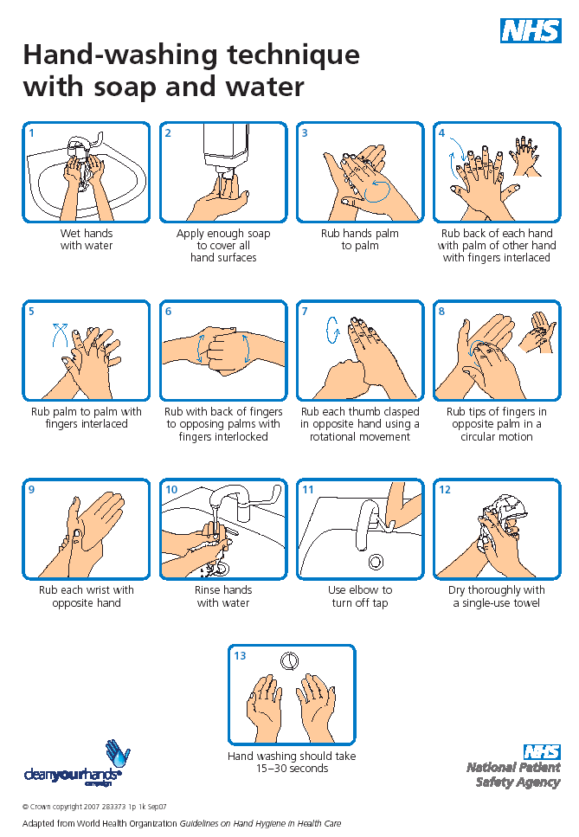

Source: [www.whatdotheyknow.com](http://www.whatdotheyknow.com)

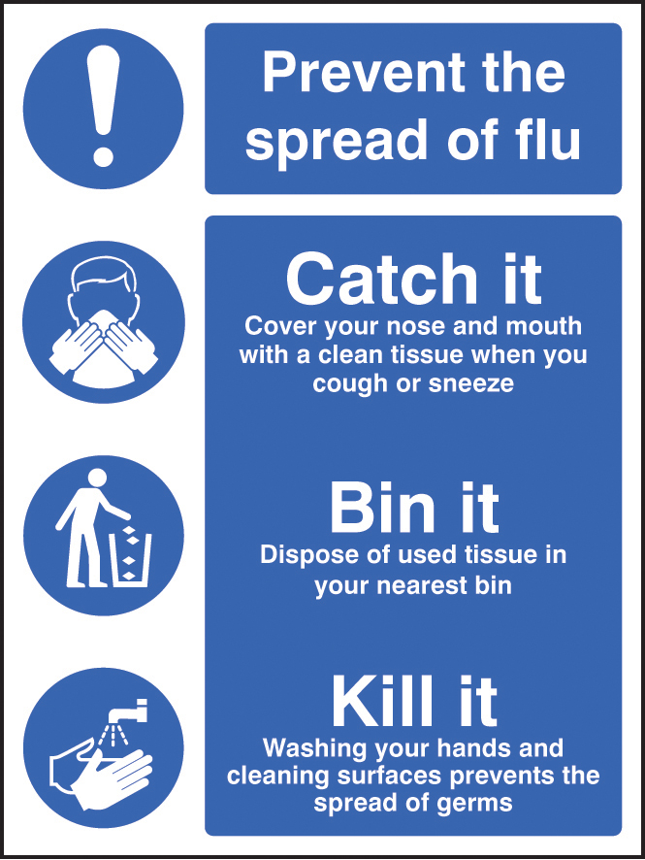

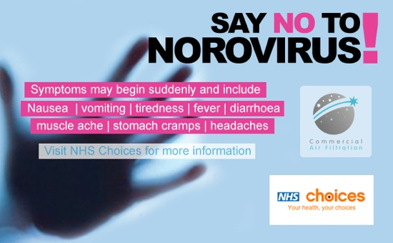

**Summary**

Isolating a patient who is suspected of having or has a proven contagious disease is the most effective way of minimising the spread of the disease to staff and patients at Swavesey Surgery . Staff must ensure that they adhere to the guidance detailed in this policy and where they have cause for concern, they are to contact Lorna Gardiner. Regular training and compliance will ensure that the risk is minimised at Swavesey Surgery.

## Annex J – Notifiable diseases[17]

**Introduction**

GPs at Swavesey Surgery have a statutory duty to notify the ‘proper officer’ at their local council or local Health Protection Team (HPT) of suspected cases of certain infectious diseases. Details of the local HPT can be found [here](https://www.gov.uk/health-protection-team).

**Notifiable diseases**

The following are notifiable diseases under the Health Protection (Notification) Regulations 2010:

* Acute encephalitis
* Acute infectious hepatitis
* Acute meningitis
* Acute poliomyelitis
* Anthrax
* Botulism
* Brucellosis
* Cholera
* COVID-19
* Diphtheria
* Enteric fever (typhoid or paratyphoid fever)
* Food poisoning
* Haemolytic uraemic syndrome (HUS)
* Infectious bloody diarrhoea
* Invasive group A streptococcal disease
* Legionnaires’ disease
* Leprosy
* Malaria
* Measles
* Meningococcal septicaemia
* Mumps
* Plague
* Rabies
* Rubella
* Severe Acute Respiratory Syndrome (SARS)
* Scarlet fever
* Smallpox
* Tetanus
* Tuberculosis
* Typhus
* Viral haemorrhagic fever (VHF)
* Whooping cough
* Yellow fever

**Reporting procedure**

GPs are to use the [registered medical practitioner notification form](https://www.gov.uk/government/uploads/system/uploads/attachment_data/file/533776/RegisteredMedicalPractitionerForm.docx) to inform the local HPT about suspected notifiable disease cases.

**Summary**

It is essential that clinicians ensure that the notification form is completed and submitted to the proper officer within three days or in the event of urgent cases, within 24 hours by telephone. Where doubt exists, guidance can be sought from:

1. [EastofEnglandHPT@phe.gov.uk; phe.EoEHPT@nhs.net](mailto:EastofEnglandHPT@phe.gov.uk;%20phe.EoEHPT@nhs.net)

Phone: [0300 303 8537 option 1](tel://0300%20303%208537%20option%201/)

Out of hours for health professionals only: phone 01603 481 221

## 

## Annex K – Toys in reception/waiting areas

**Introduction**

Contrary to popular misconception, toys are permitted in the reception and waiting areas at Swavesey Surgery and, just like all areas within the practice, are to be cleaned in accordance with the information given in the HSCA 2008.

**CQC requirements**

The CQC does not have any specific guidance that focuses on toys in GP practices. Annex H of this policy will satisfy CQC requirements and refers to the cleaning schedule for toys.

**Summary**

It is essential that Swavesey Surgery conforms to the guidance detailed in the HSCA 2008 to ensure that we: “Provide and maintain a clean and appropriate environment in manged premises that facilitates the prevention and control of infections”.

## Annex L – Staff exclusion from work

**Introduction**

Control of infection is one of the key elements of safe care in general practice. There may be on occasion a requirement to exclude staff from work and it is essential that Swavesey Surgery is prepared to deal with such occurrences.

**Recognising the requirement for exclusion**

Staff must fully understand that there may be occasions when they are not able to work due to illness. It is essential that they advise their line manager if they are suffering from the conditions listed in the table below and adhere to the timescales for exclusion; this will minimise the risk of other staff and patients being exposed to the condition.

|  |  |
| --- | --- |
| **Condition** | **Recommendations** |
| Chickenpox | Exclude staff member until lesions are dry or lesions have scabbed over. |
| Conjunctivitis | Exclude staff member for a period of 24 hours once treatment has commenced. |
| Dermatitis | If infected or discharging skin lesions, exlude staff member from clinical duties until the lesions have healed. |
| Diarrhoea and Vomiting (or either condition on its own) | Exclude staff member until they are symptom free for a period of 48 hours. |
| Head lice | Exclude staff member until they have had their first treatment. |
| Hepatitis A | Exclude staff member for a period of seven days or until fully recovered. |
| Hepatitis B & C | Exclude staff member until they have recovered. |
| Herpes Simplex | Staff members with facial Herpes Simplex are to be excluded from giving eye and neonatal care until lesions have healed. |
| HIV and AIDS | GP be consulted for advice. |
| MRSA | GP to be consulted. |
| Pandemic | Refer to current Government advice |
| Salmonellosis | Exclude staff member until they are symptom free for a period of 48 hours. |
| Scabies | Exclude staff member until they have had their first treatment. |
| Shingles | Exclude staff member from work until the lesions have scabbed over. |
| Tuberculosis | For respiratory TB, exclude staff member for a period of two weeks post treatment or until sputum smear is negative. Consult with **OH** for advice. For all other forms of TB, there is no need to exclude the staff member. |

In instances where the practice manager is not the line manager for the staff member concerned, the practice manager is to be informed of the absence at the earliest opportunity (or the deputy practice manager in their absence). Where absence affects clinical delivery or service delivery, the practice manager is to be informed immediately in line with the practice absence policy.

NB: The table above is not exhaustive

## Annex M – Hand hygiene audit

**Introduction**

This annex explains when hand washing should occur in general practice and provides a useful audit tool to enable Swavesey Surgery to conduct hand hygiene audits.

**When to decontaminate hands**

There are five moments (or occasions) when staff should was their hands:[18]

1. Immediately before every episode of direct patient contact or care including aseptic procedures
2. Immediately after every episode of direct patient contact or care
3. Immediately after any exposure to body fluids
4. Immediately after any other activity or contact with a patient's surroundings that could potentially result in hands becoming contaminated
5. Immediately after removal of gloves

Decontaminate hands, preferably with a handrub conforming to current British standards (at the time of publication of the recommendations (March 2012): BS EN 1500:1997) except in the following circumstances when liquid soap and water must be used:

* When hands are visibly soiled or potentially contaminated with body fluids **or**
* In clinical situations where there is potential for the spread of alcohol-resistant organisms (such as Clostridium difficile or other organisms that cause diarrhoeal illness)

**Good practice**

In order to facilitate good hand hygiene in a clinical environment, staff should be “bare below the elbows” when delivering direct patient care:

* Where practical, staff should not wear long sleeves. If they do, then sleeves should be rolled up to the elbow
* Watches, wrist bands and other jewellery should be removed (wedding rings are permitted as long as it is a plain band)
* Finger nails should be kept short and clean
* False nails, gel nails, nail jewellery and nail polish is not to be worn
* Any minor cuts or abrasions are to be covered with a waterproof dressing

An effective handwashing technique involves three stages: preparation, washing and rinsing, and drying. For preparation, wet hands under tepid running water before applying liquid soap or an antimicrobial preparation. The handwash solution must come into contact with all of the surfaces of the hand. The hands must be rubbed together vigorously for a minimum of 10 to 15 seconds, paying particular attention to the tips of the fingers, the thumbs and the areas between the fingers. Rinse hands thoroughly before drying with good quality paper towels.

**Audit**

The audit tool overleaf can be used to determine compliance with hand hygiene within Swavesey Surgery. Where non-compliance is identified, risk assessments and action plans should be produced and audits repeated until a satisfactory level of compliane is achieved.

Copies of the audits are to be retained as evidence for CQC and local IPC inspections.

|  |  |  |  |
| --- | --- | --- | --- |
| **Date of audit** |  | **Auditer name & role** |  |

|  |  |  |  |  |  |  |
| --- | --- | --- | --- | --- | --- | --- |
| Observation | Staff group i.e. nurse/ paramedic/ GP etc. | Did the individual wash their hands at every “moment” | Are those delivering direct patient care “bare below the elbows” | Did the staff member use the correct hand washing techniques? | Were any cuts and abrasions covered with an appropriate dressing? | Were paper towels disposed of correctly and without hand contact on the bin |
| 1 |  | Yes No N/A | Yes No N/A | Yes No N/A | Yes No N/A | Yes No N/A |
| 2 |  | Yes No N/A | Yes No N/A | Yes No N/A | Yes No N/A | Yes No N/A |
| 3 |  | Yes No N/A | Yes No N/A | Yes No N/A | Yes No N/A | Yes No N/A |
| 4 |  | Yes No N/A | Yes No N/A | Yes No N/A | Yes No N/A | Yes No N/A |
| 5 |  | Yes No N/A | Yes No N/A | Yes No N/A | Yes No N/A | Yes No N/A |
| 6 |  | Yes No N/A | Yes No N/A | Yes No N/A | Yes No N/A | Yes No N/A |
| 7 |  | Yes No N/A | Yes No N/A | Yes No N/A | Yes No N/A | Yes No N/A |
| 8 |  | Yes No N/A | Yes No N/A | Yes No N/A | Yes No N/A | Yes No N/A |
| 9 |  | Yes No N/A | Yes No N/A | Yes No N/A | Yes No N/A | Yes No N/A |
| 10 |  | Yes No N/A | Yes No N/A | Yes No N/A | Yes No N/A | Yes No N/A |
| 11 |  | Yes No N/A | Yes No N/A | Yes No N/A | Yes No N/A | Yes No N/A |
| 12 |  | Yes No N/A | Yes No N/A | Yes No N/A | Yes No N/A | Yes No N/A |
| 13 |  | Yes No N/A | Yes No N/A | Yes No N/A | Yes No N/A | Yes No N/A |
| 14 |  | Yes No N/A | Yes No N/A | Yes No N/A | Yes No N/A | Yes No N/A |
| 15 |  | Yes No N/A | Yes No N/A | Yes No N/A | Yes No N/A | Yes No N/A |
| 16 |  | Yes No N/A | Yes No N/A | Yes No N/A | Yes No N/A | Yes No N/A |
| 17 |  | Yes No N/A | Yes No N/A | Yes No N/A | Yes No N/A | Yes No N/A |
| 18 |  | Yes No N/A | Yes No N/A | Yes No N/A | Yes No N/A | Yes No N/A |
| 19 |  | Yes No N/A | Yes No N/A | Yes No N/A | Yes No N/A | Yes No N/A |
| 20 |  | Yes No N/A | Yes No N/A | Yes No N/A | Yes No N/A | Yes No N/A |

|  |
| --- |
| Findings |
|  |

|  |
| --- |
| Recommendations |
|  |

|  |
| --- |
| Actions required (and by whom) |
|  |

|  |
| --- |
| Review plan (Including date) |
|  |

1. [Health and Social Care Act 2008 Code of Practice](https://www.gov.uk/government/uploads/system/uploads/attachment_data/file/449049/Code_of_practice_280715_acc.pdf)
2. [The Health and Social Care Act 2008 - Code of Practice on the prevention and control of infections and related guidance](https://assets.publishing.service.gov.uk/government/uploads/system/uploads/attachment_data/file/449049/Code_of_practice_280715_acc.pdf)
3. [COSHH 2002](http://www.hse.gov.uk/coshh/index.htm)
4. [NICE Guidance](https://www.nice.org.uk/guidance/cg139/chapter/1-guidance)
5. [Guidance on the correct disposal of potentially hazardous clinical waste](https://www.gov.uk/guidance/healthcare-waste)
6. [Murray Medical UK](https://murraymedical.co.uk/pages/segregation-clinical-waste)
7. [Example of a Waste Transfer Note](https://www.gov.uk/government/uploads/system/uploads/attachment_data/file/311081/LIT_7932.pdf)
8. [Example of a Consignment Note](https://www.gov.uk/government/uploads/system/uploads/attachment_data/file/512167/LIT_6872.pdf)
9. [Single-use medical items: consequences and implications of reuse](https://www.gov.uk/government/uploads/system/uploads/attachment_data/file/403442/Single-use_medical_devices__implications_and_consequences_of_reuse.pdf)
10. [Health and Safety (Sharp Instruments in Healthcare) Regulations 2013](http://www.hse.gov.uk/pubns/hsis7.pdf)
11. [Managing the Risks of Sharps Injuries (NHS Employers)](http://www.nhsemployers.org/~/media/Employers/Documents/Retain%20and%20improve/Health%20and%20wellbeing/Managing%20the%20risks%20of%20sharps%20injuries%20v7.pdf)
12. [HSE Sharps injuries – What you need to do](http://www.hse.gov.uk/healthservices/needlesticks/actions.htm)
13. [HSE Regulations 2013](https://www.sor.org/system/files/article/201303/Sharps%20Regs%202013.pdf)
14. [HSE Health Services Information Sheet 7](http://www.hse.gov.uk/pubns/hsis7.pdf)
15. [Medical Protection Society Specimen Handling](https://www.medicalprotection.org/uk/practice-matters-issue4/risk-alert-infection-control)
16. [UN3373 Regulations](http://www.un3373.com/info/regulations/)
17. [Notifiable diseases and causative organisms: how to report](https://www.gov.uk/guidance/notifiable-diseases-and-causative-organisms-how-to-report#list-of-notifiable-diseases)
18. [NICE Prevention and control of healthcare associated infections in primary care](https://pathways.nice.org.uk/pathways/prevention-and-control-of-healthcare-associated-infections#path=view%3A/pathways/prevention-and-control-of-healthcare-associated-infections/prevention-and-control-of-healthcare-associated-infections-in-primary-and-community-care.xml&content=view-node%3Anodes-hand-decontamination)